Sources of support
If you or someone you know is experiencing distress, please ask for help. Support is always available. Below are options for online and telephone information and support in Australia.

Acknowledgement of Country
The National Suicide Prevention Office (NSPO) acknowledges Aboriginal and Torres Strait Islander peoples as the Traditional Custodians of the lands and waters on which we live, work and learn.
Recognition of lived experience
The NSPO recognises the individual and collective contributions of those with lived and living experience of suicide. People who experience suicidal thoughts, have survived suicide attempts, cared for a person in suicidal crisis or have lost a loved one to suicide demonstrate tremendous generosity through providing their expertise and insights. Every person’s journey is unique and a valued contribution to Australia’s commitment to suicide prevention reform.
Lifeline:  13 11 14  Lifeline.org.au  Suicide Call Back Service:  1300 659 467  Suicidecallbackservice.org.au  Beyond Blue:  1300 224 636  Beyondblue.org.au  MensLine Australia:  1300 789 978  Mensline.org.au  Kids Helpline:  1800 551 800  Kidshelpline.com.au | headspace:  1800 650 890  ReachOut:  au.reachout.com  Aboriginal and  Torres Strait Islander Peoples:  13 YARN (13 92 76)  LGBTIQ+ community:  1800 184 527  Qlife.org.au  Culturally and linguistically  diverse communities:  embracementalhealth.org.au  Head to Health:  Headtohealth.gov.au

Introduction
The National Suicide Prevention Strategy (the Strategy) has been developed through extensive research, collaboration and consultation with experts in suicide prevention across academia, the suicide prevention sector and people with lived and living experience of suicide prevention. The Strategy has also been extensively consulted on and reviewed by relevant Commonwealth, state and territory departments and agencies.
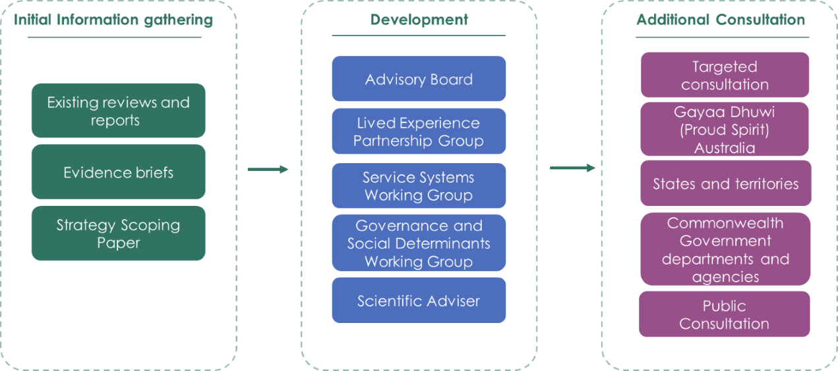

Figure 1: Overview of Strategy development and consultations

Initial Information gathering
- Recommendations from more than 30 existing reviews and reports, including the National Suicide Prevention Adviser’s Final Advice, and the Productivity Commission Inquiry Report into Mental Health were analysed and used to establish an understanding of previous work in this area.
- The National Suicide Prevention Office (NSPO) commissioned evidence reviews that were produced through the LifeWays network. These drew on domestic and international academic expertise and provided an evidence base for the Strategy.
- A public consultation on a scoping paper outlining the composition and development of the Strategy was conducted in November 2022. Input received informed the development process.

Advisory Groups
The Development of the Strategy was guided by:
- The NSPO’s Advisory Board and Lived Experience Partnership Group
- Two working groups composed of individuals with specific subject matter expertise appointed through expression of interest.
- Scientific Advisor, Prof. Jane Pirkis.
Membership of these groups is outlined at the end of this document.

Targeted Consultation
Groups disproportionately impacted by suicide
Targeted consultations with specific groups disproportionately impacted by suicide were conducted to inform the development of the Strategy. These consultations included:
- Participants at the Lived Experience Summit in 2023.
- Consultation conducted by Suicide Prevention Australia on behalf of the NSPO with 95 people over 10 sessions focused on: men; regional, rural and remote communities; people with disability; CALD communities; and older Australians.
- Consultation conducted by LGBTIQ+ Health Australia on behalf of the NSPO with 62 people over 6 sessions focused on LGB, trans and gender diverse, Intersex, Aboriginal and CALD communities, and LGBTIQ+ people with disability.
- The Office for Youth Mental Health and Suicide Prevention Youth Advisory Group.
- Consultation with a group of 15 young people with lived and living experience of suicide recruited through the NSPOs national networks.
Table 1: Summary of targeted consultations with people with lived and living experience of suicide
Consultations | No Consultations | No Attendees
Roses in the Ocean Lived Experience Summit | 1 | 230
Suicide Prevention Australia | 10 | 95
LGBTIQA+ Health Australia | 6 | 62
Mental Health & Suicide Prevention Youth Advisory Group – Office for Youth | 1 | 7
Consultation with Young People | 1 | 15
Total | 19 | 401

Aboriginal and Torres Straits Islander communities - Gayaa Dhuwi (Proud Spirit) Australia
- The NSPO works closely with Gayaa Dhuwi to ensure alignment between the Strategy and the National Aboriginal and Torres Strait Islander Suicide Prevention Strategy as well as the Gayaa Dhuwi (Proud Spirit) Declaration Implementation Plan.

Commonwealth Government departments and agencies
- Throughout December 2023 to February 2024 the NSPO consulted with all Commonwealth departments and agencies with relevance to actions within the draft Strategy.
- This occurred first through an interdepartmental committee and then through individual briefings, consultation and the receipt of feedback from each relevant department and agency. All feedback was applied.
- Explicit endorsement for the Strategy to proceed to public consultation was sought. No objections were raised by any department or agency.
- In November 2024, following the public consultation, the NSPO met again with Senior Officials from all relevant portfolios to secure endorsement for adoption of the document as the National Suicide Prevention Strategy.
Table 2: List of Commonwealth departments and agencies consulted
List of Commonwealth Government Departments and Agencies consulted
Attorney-General’s Department (National Office for Child Safety; Justice and Communities Group; Children and Families Division, and Human Rights Branch)
Australian Human Rights Commission (Children’s Rights; Human Rights Education; and Projects and Partnerships)
Comcare
Department of Defence
Department of Education
Department of Employment and Workplace Relations (Safety and Industry Policy)
Department of Finance
Department of Home Affairs
Department of Infrastructure, Transport, Regional Development, Communications and the Arts (Broadcasting and Gambling Regulation Division; Online Safety, Media and Platforms Division; and Regional Development and Local Government Division)
Department of Social Services (Security Section - Pensions, Housing and Homelessness, Social security, Women’s Safety, Families and Communities Group; Participation and Family Payments Group)
Department of Veteran’s Affairs
eSafety Commissioner
National Emergency Management Agency
Federal Circuit and Family Court
National Indigenous Australian’s Agency
Treasury
Safe Work Australia

States and territories
- The NSPO worked through the Jurisdiction Collaborative Forum (JCF), which includes suicide prevention leads from all states and territories as well as the National Aboriginal Community Controlled Health Organisation (NACCHO) and the Commonwealth Department of Health and Aged Care.
- Throughout January and February 2024, the NSPO also had further detailed consultations with officials from all states and territories.
- In December 2024, following the public consultation, the NSPO once again briefed suicide prevention leads from all states and territories. The Strategy was then considered by the Health Chief Executives Forum.
Table 3: List of jurisdictions consulted
Jurisdiction | Department/ agency
ACT | ACT Department of Health
NSW | NSW Ministry of Health, NSW Mental Health Commission  NSW Mental Health Commission
NT | Department of the Chief Minister and Cabinet  Department of Health
QLD | Department of Health  QLD Mental Health Commission
SA | Office of Chief Psychiatrist  Wellbeing South Australia
Tasmania | Department of Health
Victoria | Suicide Prevention and Response Office
WA | Department of Health  WA Mental Health Commission

Membership of Advisory Boards and Working Groups
Table 2: Membership of the Lived Experience Partnership Group
Name | State or Territory of residence
Susan Edgar (Chair) | Western Australia
Ken Barnard | New South Wales Nov 22 – Sep 24
Amy Bertakis | New South Wales
Benjamin Brien | New South Wales
Ben Farinazzo | Australian Capital Territory Nov 22 – Apr 24
Jordan Frith | Queensland
Isha Garg | Victoria
Charles Nasir | Northern Territory
Imbi Pyman | Victoria
Chaya Rainbird | Tasmania
Refugee (name withheld for cultural reasons) | South Australia
Jo Riley | New South Wales
Chris Trupp | Queensland
Luke Woods | Queensland

Table 3: Membership of the Advisory Board
Name
Dr Alan Woodward (Chair)
Prof Steve Allsop
Gwen Cherne
Prof Henry Cutler
Prof Pat Dudgeon
Prof Kathy Eagar
Bronwen Edwards
Prof Karen Fisher
Prof Sharon Friel
Graeme Holdsworth
Pino Migliorino
Nicolas Parkhill
Kym Peake
Dr Wendy Southern PSM
Chief Executive Officer, Gayaa Dhuwi (Proud Spirit) Australia
Chief Executive Officer, National Mental Health Commission
Chief Executive Officer, Suicide Prevention Australia

Table 4: Membership of Working Groups
Governance and Social Determinants Working Group | Service Systems Working Group
Name | Name
Peter Anderson | Katrina Armstrong
Joe Ball | Monica Barolits-McCabe
Melinda Benson | Marion Byrne
Stephen Carbone | Maria Cassaniti
Gillian Clark | Joyce Chia
Zaccariah Cox | Sam Cruickshank
Nicole Falkiner | Mark Ellis
Thomas Jessup | Kate Finch
Anna Louise Kimpton | Kerry Gleeson
Time Keane | Erin Halligan
Kathryn Mandla | Nikki Jamieson
Stephen Scott | Luke Lindsay
Fiona Shand | Dan Mobbs
Staphanie Trainor | Mike Nolan
Addie Wootten | Jay Pickard
 | Nicholas Proctor
 | Jo Robinson
 | Hope Saba

