Sources of support

If you or someone you know is experiencing distress, please ask for help. Support is always available. Below are options for online and telephone information and support in Australia.

Acknowledgements

Acknowledgement of Country

The National Suicide Prevention Office (NSPO) acknowledges Aboriginal and Torres Strait Islander peoples as the Traditional Custodians of the lands and waters on which we live, work and learn.

Recognition of lived experience

The NSPO recognises the individual and collective contributions of those with lived and living experience of suicide. People who experience suicidal thoughts, have survived suicide attempts, cared for a person in suicidal crisis or have lost a loved one to suicide demonstrate tremendous generosity through providing their expertise and insights. Every person’s journey is unique and a valued contribution to Australia’s commitment to suicide prevention reform.

|  |  |
| --- | --- |
| **Lifeline:**  13 11 14  [Lifeline.org.au](http://www.lifeline.org.au)  **Suicide Call Back Service:**  1300 659 467  [Suicidecallbackservice.org.au](https://www.suicidecallbackservice.org.au/)  **Beyond Blue:**  1300 224 636  [Beyondblue.org.au](https://www.beyondblue.org.au/)  **MensLine Australia:**  1300 789 978  [Mensline.org.au](https://mensline.org.au/)  **Kids Helpline:**  1800 551 800  [Kidshelpline.com.au](https://kidshelpline.com.au/) | **headspace:**  1800 650 890  **ReachOut:**  [au.reachout.com](https://au.reachout.com/)  **Aboriginal and**  **Torres Strait Islander Peoples:**  13 YARN (13 92 76)  **LGBTIQ+ community:**  1800 184 527  [Qlife.org.au](https://qlife.org.au/)  **Culturally and linguistically  diverse communities:**  [embracementalhealth.org.au](https://embracementalhealth.org.au/)  **Head to Health:**  [Headtohealth.gov.au](https://www.headtohealth.gov.au/) |

Contents

Acknowledgements Error! Bookmark not defined.

Public Consultation Summary 4

Development of the draft advice on the Strategy 4

Public consultation process 4

Breakdown of submissions 4

Summary of feedback 4

Key Feedback themes 6

Strategy implementation 6

Service supports 6

Families and carers 6

Workforce capacity and capability 7

The mental health system and suicide prevention 7

Groups disproportionately impacted by suicide; and 7

Framing and accessibility of the document. 7

## Public Consultation Summary

### Development of the draft advice on the Strategy

The draft Advice on the National Suicide Prevention Strategy (the Strategy) was developed by the National Suicide Prevention Office (NSPO) in collaboration with a Lived Experience Partnership Group and Advisory Board, Scientific Advisor, two working groups, and a Jurisdictional Collaborative Forum. This has ensured the Strategy incorporates the perspectives of people with lived and living experience of suicide as well as those with expertise in suicide prevention across policy, research and service delivery, public health, social policy, service design, delivery and evaluation. For more information on the development of the Strategy, please see: <https://www.mentalhealthcommission.gov.au/nspo/publications/development-national-suicide-prevention-strategy-2023-2035>

### Public consultation process

The public consultation opened on 10 September 2024 (World Suicide Prevention Day) and closed 27 October 2024. The consultation sought feedback on how well the Strategy articulated the work required to achieve long-term change in suicide prevention, which actions were considered the highest priority for implementation, any gaps in what the Strategy covered, and ask for proposed changes to improve the Strategy.

In response, **311 submissions** were received, including 199 submissions from individuals and 112 from organisations.

### Profile of those who provided submissions

Individuals who provided submissions to the public consultation via the online survey had the option to provide demographic information. Of the 199 individuals who provided submissions, 161 people responded to the demographic questions. A summary of these demographics is provided in this paper.

### Summary of feedback

Overall, there was **strong endorsement for the Strategy**. Submissions commended the comprehensiveness of the model and acknowledged the **holistic approach to suicide prevention as key to enabling long-term improvements.**

A key area of strength identified by submissions was the Strategy’s focus on both individual risk factors and the social determinants of suicide, such as inequity, housing and economic insecurity, access to healthcare, social inclusion and discrimination.

Feedback praised how the conceptualisation of suicide prevention in the Strategy represents a shift from a traditional pathological or medical-centric approach to a genuinely preventive approach to suicide prevention. Respondents appreciated the emphasis on addressing risk factors that increase the likelihood of suicidality, and increasing protective factors, such as wellbeing, across the population.

However, there were several calls for increased Government commitment. Several stakeholders noted that the framing of the document as “advice on” a suicide prevention strategy does not convey the necessary urgency and commitment. Stakeholders expressed a preference to see the document released as a Government-endorsed ‘National Suicide Prevention Strategy’. There were also calls for the Strategy to outline roles, responsibilities and a targeted action plan.

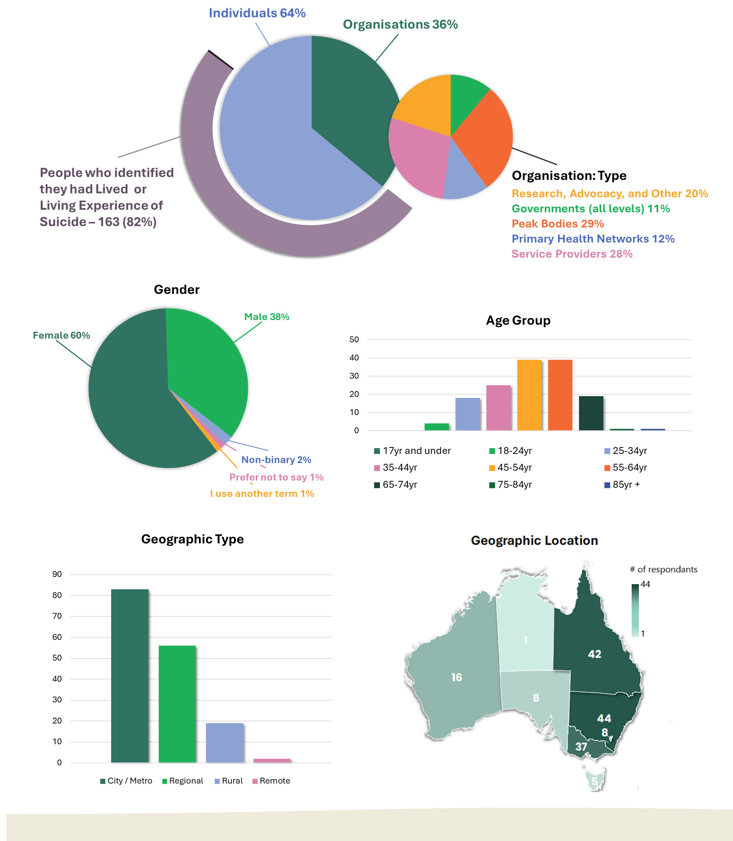

### Key Feedback themes

All submissions through the public consultation period were independently analysed to identify key themes and insights. From the analysis, seven key themes emerged:

1. Strategy implementation
2. Service supports
3. Families and carers
4. Workforce capacity and capability
5. The mental health system and suicide prevention
6. Groups disproportionately impacted by suicide; and
7. Framing and accessibility of the document.

These themes have been thoroughly examined and where appropriate, changes to the Strategy were incorporated to reflect the feedback provided.

##### Strategy implementation

Feedback expressed a critical need for strong, ongoing commitment to the implementation of strategy actions. It highlighted a risk to implementation should action plans not be developed and roles and responsibilities of each level of government remain unidentified. There were several calls for clearer governance arrangements and greater commitment of funding: short, medium, and long term.

Actions taken:

* Clarified roles for the tracking of implementation of the Strategy as well as outcomes.
* Emphasised the need for governance structures that are fit for whole-of-governments approach and the importance of formalising roles and responsibilities through the next iteration of the *National Mental Health and Suicide Prevention Agreement.*

##### Service supports

Feedback received emphasised the importance of the accessibility and affordability of support services for people experiencing suicidal distress. It also highlighted the need to ensure that services are tailored and appropriately available to suit the needs of the populations they support.

Actions taken:

* Reviewed content related to affordability to ensure it appropriately addressed identified barriers.
* Inclusion of content highlighting the importance of services being readily available and accessible during hours that match the needs of the populations they support.

##### Families and carers

Feedback received emphasised the importance of the role of and need for support for people who are bereaved by suicide, and those who care for people who experience suicidality. Feedback highlighted this as a strength in the Strategy.

Actions taken:

* Reviewed content to ensure the importance of including family, carers and kin in support interactions was adequately addressed and contained appropriate actions.
* Reviewed content to ensure the importance of providing family, carers and kin themselves with support was adequately addressed and contained appropriate actions.

##### Workforce capacity and capability

Feedback emphasised the need for attraction, retention, and upskilling of the current suicide prevention workforce, the benefit of a multi-disciplinary approach to care, and the integration of lived experience across the breadth of the suicide prevention workforce. Feedback expressed support for the way the Strategy articulates these needs, particularly the lived experience driven approach, urging commitment to these actions.

Actions taken:

* Reviewed workforce content across the Strategy and in particular, action related to the development of a National Suicide Prevention Workforce Strategy. Ensure the proposed scope for the Workforce Strategy reflects the key issues identified in the feedback received.

##### The mental health system and suicide prevention

Feedback suggested clearly describing both the connection and distinction between the mental health system and suicide prevention.

Actions taken:

* Added clarification to the introduction of the Strategy that articulates the importance of a well-functioning mental health system to effective suicide prevention.

##### Groups disproportionately impacted by suicide; and

Feedback highlighted a strong desire for visibility of specific population groups who are disproportionately impacted by suicide, while also commending the approach taken in the Strategy to focus on addressing the underlying factors that lead to disproportionate impacts.

Actions taken:

* Emphasised the approach to disproportionately impacted population groups taken within the Strategy. Articulated the focus on intersectionality, non-modifiable risk factors, and how these factors translate into the way the actions are characterised.
* The NSPO intends to prepare supplementary resources in support of the Strategy, that explicitly explore how the Strategy is intended to improve outcomes for groups disproportionately impacted by suicide.
* Strengthening of related actions to include reference to the need for increased data and research related to the association between neurodivergent conditions and suicide, to address strong feedback.
* Review of the LGBTIQ+ language used throughout the Strategy and amendments to reflect appropriate definitions and use as advised by key LGBTIQ+ organisations while maintaining alignment with government style manuals.

##### Framing and accessibility of the document.

Feedback raised concerns about the framing of the Strategy as ‘advice’. Additionally, feedback emphasised the need for document accessibility.

Actions taken:

* The Strategy has been provided to Government for their consideration to release as *‘The National Suicide Prevention Strategy 2025-2035’.*
* A summary version of the Strategy is being developed. This provides a shorter overview of the approach and uses more accessible, plain English language. The summary version is being prepared so as to be available for release with the full version of the Strategy.
* Revisiting the ‘means restriction’ sub-objective within the Strategy. It’s location within the model was changed and related actions were included in more appropriate areas to strengthen the logic of the Strategy model.
* Simplification of the action numbering system.

