**Why we need a national suicide prevention strategy**

Each day in Australia, nearly 9 people die by suicide and 150 people attempt to take their own life. That is more than 3,000 lives lost to suicide and 55,000 suicide attempts each year.

It is estimated that around 135 people are affected by each suicide death. Each loss of life is heartbreaking, and leaves families, friends, colleagues and community members devastated.

Beyond the human impacts, the economic cost of suicide and suicide attempts is enormous. It is estimated to cost the economy $30.5 billion each year.

But deaths and attempts are only part of the issue. Suicidal thoughts and behaviours are widespread. Research shows that in 2020-2022, 3.3 million Australians aged 16-85 reported experiencing suicidal thoughts or behaviour at some point in their lives and 1.7 million people aged 16 – 85 had self-harmed in their lifetime.

As a result, most Australians will be impacted by suicide, suicide attempts, or suicidal distress at some point in their lives.

But it does not have to be this way. Most suicides are preventable.

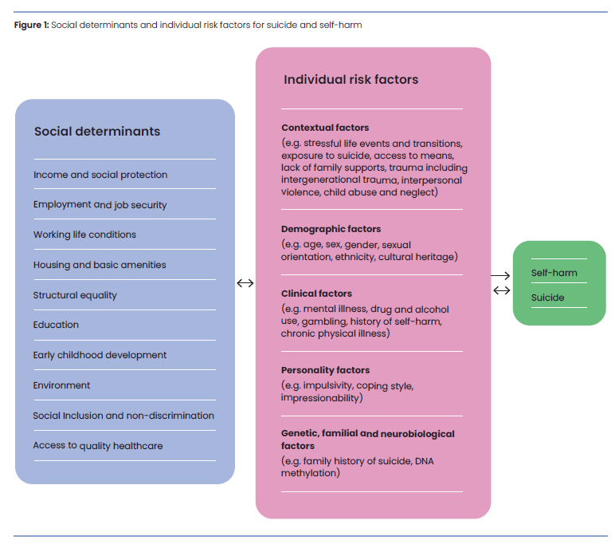The National Suicide Prevention Strategy (the Strategy) describes a national approach that aims to reduce suicide deaths and attempts by preventing suicidal distress from emerging in the first place, and by ensuring the best support is available to those who need it.

Why do people die by suicide?

Suicide and suicidal distress are not just about mental illness. Suicidal distress is a human response to overwhelming suffering. There can be many different factors that contribute to suicidal distress. They can include a lack of resources that people need (like money, housing and health care), stressful or traumatic life experiences, health issues such as mental illness or drug and alcohol use, and individual characteristics like genetics, personality and age or cultural heritage (Figure 1). These factors can combine to increase the likelihood of suicidal distress.

This understanding of suicide is supported by the stories of thousands of Australians with lived and living experience of suicide who link their suicidal thoughts and behaviours to early life exposure to violence, trauma, family conflict or bereavement as well as alcohol and other drug challenges, discrimination and life stressors around the time of a suicide attempt.

It also reflects Aboriginal and Torres Strait Islander concepts of social and emotional wellbeing, which emphasise that wellbeing is inextricably linked not only to an individual’s mental health, but to connections between people, family, kin and community, as well as connections to land, culture, spirituality, ancestry and the impacts of social determinants on people and communities.

Understanding suicide in this way tells us that trying to prevent suicide solely from a mental health perspective is unlikely to be successful. While the Strategy focuses on aspects of the mental health system that are particularly critical to improving suicide prevention outcomes, it also recognises that to be truly effective, our efforts must address relevant socio-economic factors as well.

Who is most affected?

No one in Australia is immune to the impacts of suicide, although some groups experience much higher suicide rates. These include males, young people, older people, members of the Aboriginal and Torres Strait Islander community, members of the LGBTIQ+ community, people with mental illness, people with disability, veterans, refugees and people who are seeking asylum, and those who have lost loved ones to suicide.

It is important to understand that this is not due to inherent vulnerabilities in these communities, but rather due to the unequal impacts of social and economic factors. And, while there are differences in the way issues affect each community, there are common themes. These include experiences of discrimination, economic insecurity, stigma, poor health outcomes, and reduced access to supports capable of responding to their needs.

It is therefore important that our approach to addressing the disproportionate rates of suicide experienced by some communities should shift to an approach where the focus is on addressing inequities to prevent the emergence of suicidal distress, and on ensuring that supports are better equipped to respond to the circumstances that people experience.

## What is in the Strategy?

The Strategy draws on the latest research, evidence, and insights from people with lived and living experience of suicide to outline a comprehensive approach to suicide prevention. It builds on work already occurring across Australia, drawing on existing agreements, reports, and specially commissioned work. The Strategy has been designed to work alongside the National Aboriginal and Torres Strait Islander Suicide Prevention Strategy, developed by Gayaa Dhuwi (Proud Spirit) Australia.

The Strategy is organised into three domains:

**Prevention of suicidal distress** describes what is required to reduce the likelihood of suicidal distress arising. This involves strengthening the wellbeing of communities and better supporting those who are struggling with factors we know can lead to suicidal distress.

**Support for people experiencing suicidal thoughts and behaviours and those who care for them** describes the elements required for an effective support system. To provide high-quality support, these components must operate in each part of the support system and across the system as a whole.

**Critical enablers** are the administrative and structural elements that must be present to achieve the objectives of the Prevention and Support domains.

Figure 1: The Strategy model

The three domains and their objectives are not designed to be acted on in isolation, but as a collective package, with each being of equal importance.

# Prevention

A comprehensive approach to suicide prevention must do more than support people who are experiencing suicidal distress. It must reduce the likelihood of people experiencing suicidal distress in the first place.

High levels of community wellbeing can have a protective effect against suicidal distress. To build community wellbeing, policies need to be informed by human rights and ensure that people have quality of life, including a sense of meaning and purpose. There also needs to be a focus on equity to ensure that the disadvantages that drive high rates of suicide in some communities are addressed.

In addition, harmful socio-economic stresses need to be addressed. Experiences such as childhood abuse and neglect, alcohol and drug-related harm and intimate partner violence are known to increase risk of suicide. Reducing their prevalence and providing support to people affected can prevent suicidal distress and reduce the risk of suicide.

The Strategy focuses on five areas that are associated with wellbeing or increased risk of suicidal distress: safety; good health; economic security; social inclusion; and navigating life transitions.

### Key objective: Safety and security

Enhancing wellbeing from a safety and security perspective aims to build a safer, more stable and equitable society to prevent exposure to risk, discrimination and abuse. This involves upholding human rights in all aspects of life, and ensuring people can experience positive and respectful interpersonal and intimate partner relationships. It also involves reducing the occurrence of violence, abuse, neglect, racism and discrimination, and providing support to people impacted by these experiences.

#### Summary of recommended actions:

* Ensure a human rights-informed approach to suicide prevention, including through engaging with the Australian Human Rights Commission when reviewing and advising on reform.
* Address family, domestic and sexual violence, as well as child abuse and neglect.
* Ensure mental health services work in trauma-informed and culturally safe ways.
* Provide services to support children and young people who are impacted by adversity.
* Protect people from discrimination, racism, abuse, violence, neglect and exploitation.
* Provide support and guidance for schools to implement bullying prevention programs.
* Build capability of employers to manage psychosocial hazards at work.
* Build suicide prevention into disaster recovery efforts.
* Improve the safety and security of people with disability.

### Key objective: Good health

People who have good mental and physical health are better able to participate in employment, education and social activities, and are better protected against suicide. Healthier communities can be built by equipping people with the knowledge, skills and resources to maintain their mental and physical health, and by improving access to physical and mental health care.

#### Summary of recommended actions:

* Improve the preventative health system and promote healthy behaviours in relation to diet, exercise and substance use.
* Continue to expand and enhance services for people experiencing mental ill health, particularly severe and enduring mental illness.
* Improve the capability of healthcare services to identify and respond to suicidal distress.
* Co-design approaches for safe and inclusive health care for LGBTIQ+ people.
* Prevent and minimise harms from alcohol and other drug use as well as gambling.

### Key objective: Economic security

Economic security provides people with the ability to buy necessities, gives a sense of purpose, promotes social engagement, and allows choice and control over important aspects of life. Economic security is associated with improved mental and physical health.

On the other hand, people who move from financial security to uncertainty can experience an almost immediate but short-term increase in their suicide risk. During periods of economic downturn, national suicide rates generally increase, and poorer communities experience higher rates of suicide than the rest of the population.

Building and maintaining economic security is therefore an essential aspect of suicide prevention. This can be achieved by ensuring that people have access to meaningful and stable employment and education, and by providing people who do experience financial distress with the economic supports that can prevent distress from escalating into suicidal thoughts and behaviours.

#### Summary of recommended actions:

* Improve equitable access to safe, meaningful and secure employment in psychologically safe workplaces, and maintain the social security safety net (including regular consideration of payment rates).
* Ensure equitable access to vocational and tertiary education.
* Build financial literacy.
* Strengthen connections between financial counselling, mental health and suicide prevention supports.
* Provide equitable and inclusive access to safe, secure and affordable housing.
* Ensure that people retiring, leaving the workforce, or requesting early access to superannuation are offered financial, physical health and mental health supports.

### Key objective: Social inclusion

People thrive when they feel included in communities, connected to others, and have a sense of belonging. This builds wellbeing and reduces the occurrence of suicidal thoughts and behaviours. An important part of suicide prevention is therefore building inclusive and affirming communities. This can be done by providing opportunities for people to engage socially and culturally, combatting loneliness, and reducing experiences such as racism, discrimination and stigma.

Summary of recommended actions:

* Work with communities to increase opportunities for building cultural connection and sense of belonging.
* Address loneliness and social exclusion, particularly for groups that experience them at higher rates.
* Co-design culturally appropriate programs for communities who experience stigma, discrimination and internalised shame.

### Key objective: Navigating life transitions

There are many periods in life that involve substantial change – for example early childhood, moving to adulthood, losing employment, starting a family, facing relationship challenges, having legal difficulties, or growing older. The upheaval experienced during these times can lead to significant distress. Protection against suicidal distress and suicide can be built by ensuring that people are proactively equipped with the skills and knowledge to navigate these periods well, and by ensuring that appropriate supports are available to assist them through difficult transitions when needed.

#### Summary of recommended actions:

* Improve life skills and mental health support programs for children and young people.
* Improve the quality of aged care services and support for people transitioning into supported living arrangements.
* Increase access to programs for first time parents.
* Provide subsidised access to counselling for people going through separation and divorce.
* Provide information, referrals and supports for people involved in family law and domestic violence matters.
* Provide proactive mental health, suicide prevention and transition support programs for people in prison or youth detention settings.
* Provide universal access to counselling and practical supports for people who are bereaved.
* Implement the Government’s response to the *Royal Commission into Defence and Veteran Suicide.*
* Increase support for LGBTIQ+ young people and their families, carers and kin, to facilitate good mental health and supportive relationships.

# Support

When people do experience suicidal distress, it is critical that there is effective support available to them, and to their families, carers and kin. This support must recognise suicidal distress as a human response to overwhelming suffering. It must be compassionate and effective and must aim to not only address the causes of suffering, but to restore wellbeing.

Support relates not only to responses from formal health and mental health services, but also to community settings and other services.

The Strategy outlines five essential components of an effective support system: a culture of compassion; accessibility; system-level coordination; holistic approaches; and increased connection. These are needed in each individual service as well as across the whole support system.

### Key objective: Culture of compassion

#### Hurtful attitudes and behaviours towards people experiencing suicidal distress can limit engagement with supports. A shift to a culture of compassion, both in the media, through service delivery and the community will help people who experience suicidal distress to be connected with supports. It is critical in suicide prevention that people with suicidal thoughts and behaviours are not met with damaging attitudes that make them less likely to seek support, but instead are met with understanding and respect. This should also be reflected in the media where action needs to be taken to reduce negative attitudes towards mental health and suicide and follow best practice guidelines when reporting on suicidal behaviour.

#### Summary of recommended actions:

* Reduce suicide stigma across the community and support services
* Minimise community exposure to information that may promote or encourage suicide in media or online platforms.
* Provide key people – that is, those across services and the general community, with the skills to identify and support people experiencing suicidal distress.
* Build compassionate cultures within support services.

### Key objective: Accessibility

Ensuring that people who experience suicidal thoughts and behaviours get support as early as possible requires services to be readily accessible. This means that services can be easily found and are available regardless of where a person lives, their needs, or their disability status or type. Services should also be affordable and should be delivered in a way that is appropriate and acceptable with the consideration of people’s unique culture, beliefs, identity, ability and care needs.

#### Summary of recommended actions:

* Ensure supports are available and affordable by removing barriers to access.
* Expand the capacity of services in line with population needs.
* Better utilise technology to improve access, particularly for people in rural, regional and remote areas.
* Provide rapid joint responses to emergency calls (i.e., police/ambulance attend emergencies with a clinician or suicide prevention peer worker).
* Develop best-practice safe space services as alternatives to emergency departments.
* Provide tailored suicide prevention support for populations that are disproportionately impacted by suicide.

### Key objective: System-level coordination

When people connect with services, it is important that the different types of services they need work together effectively and seamlessly to promote sustained recovery. This is particularly vital for people who have recently attempted suicide and for people who experience chronic suicidal thoughts and behaviours.

#### Summary of recommended actions:

* Create care pathways to provide consistent, evidence-informed support and improved outcomes.
* Expand aftercare services to be available to anyone who has recently self-harmed, attempted suicide or experienced a suicidal crisis, and integrate suicide prevention peer workers into these services.
* Improve access to aftercare support for children and young people, and for their families, carers and kin.
* Provide dedicated care coordination roles to support people with chronic suicidal thoughts and people with suicidal thoughts who have complex needs.
* Make it easier to safely share clinical information across the health system – for example, by removing technological barriers.

### Key objective: Holistic approaches

The support that people receive should be focussed on understanding their unique circumstances and on addressing the underlying drivers of their distress regardless of whether they relate to physical health, mental health, substance use, financial, legal or interpersonal stressors. These supports should also be available beyond times of crisis so that they restore and sustain wellbeing.

#### Summary of recommended actions:

* Ensure crisis services, including emergency departments, provide consistent, effective support.
* Shift from assessing people’s level of suicide risk, towards assessing people’s needs.
* Establish partnerships between health and non-health services to collaboratively meet people’s full range of needs.
* Establish community-based supports for people who experience chronic suicidal thoughts and their families, carers and kin.

### Key objective: Holistic approaches

The supports provided to people who experience suicidal thoughts and behaviours should ensure that they are empowered to feel connected to other people and the community. Improving social connection can build and sustain wellbeing, which has a protective effect against suicide by cushioning the impact of risk factors.

#### Summary of recommended actions:

* Reduce barriers to inclusion of families, carers and kin in care planning.
* Provide support to families, carers and kin through carer peer work roles as well as in-person and online support programs.
* Test social prescribing approaches that connect people with informal supports to improve social and community connections.

# Critical enablers

The critical enablers are the administrative and structural elements that are needed to implement and sustain the suicide prevention approach outlined in the Prevention and Support domains. The critical enablers are intended to be long-term activities that will help the system to continually improve.

### Critical enabler: Improved governance

The Strategy points out that suicide prevention involves not only mental health or health, but issues such as domestic and family violence, child abuse, racism and discrimination, employment, education and finance. For this reason, suicide prevention must involve many different government departments and all levels of government including the Australian Government, state and territory, and local governments. In practice, this means that there needs to be improved clarity about the roles and responsibilities of each level of government, improved partnerships and shared decision-making with communities, and a strengthened approach to place-based and community-led initiatives so that efforts are tailored to local needs.

#### Summary of recommended actions:

* Establish a ‘suicide prevention in all policies’ approach that reviews all new policies for potential impacts on suicide and builds the suicide prevention capability of policy makers.
* Improve agreements between parts and levels of government to strengthen clarity on roles and responsibilities and promote partnerships with Aboriginal and Torres Strait Islander leadership.
* Improve governance and funding mechanisms to enable long-term regional planning and commissioning of suicide prevention activities.

### Critical enabler: Embedded lived experience

People with lived and living experience have the greatest insight into what works, what does not work, and what is missing in suicide prevention. For suicide prevention efforts to be truly effective, it is vital that people with lived and living experience of suicide have a central role in designing, delivering, governing and evaluating suicide prevention activities.

#### Summary of recommended actions:

* Build capability of governments to meaningfully engage with people with lived and living experience in ways that are safe, empowering and meaningfully guide decision-making.
* Establish equitable and inclusive approaches that enable the broadest range of people with lived and living experience to participate.
* Embed lived and living experience roles and bodies into relevant decision-making structures and monitor the impact this has.

### Critical enabler: Available and translated evidence

An effective approach to suicide prevention is underpinned by strong evidence and evaluation. This requires a coordinated approach to data collection and research, translation of evidence into practice in collaboration with people with lived and living experiences of suicide, and a dedication to high quality evaluation to ensure we know what works.

#### Summary of recommended actions:

* Improve the coordination and sharing of data related to suicide.
* Collect data to address current gaps especially about factors that are known to contribute to suicide and improve the visibility of groups disproportionately impacted by suicide.
* Improve suicide prevention research.
* Strengthen evaluation of government funded activities.
* Develop and implement a National Suicide Prevention Outcomes Framework.
* Build the capability of government agencies, primary health networks and local hospital networks to translate research into practice.

### Critical enabler: Capable and integrated workforce

The most foundational requirement of effective suicide prevention is a strong, capable and well-supported suicide prevention workforce. The Strategy considers the ‘suicide prevention workforce’ as anyone involved in providing compassionate and effective responses to people in suicidal distress and to those impacted by the inequities that can lead to suicidal distress. All parts of this workforce must be empowered to understand their role in suicide prevention, have the capability to perform their role, and be sufficiently supported to operate effectively and compassionately in a sustainable way.

#### Summary of recommended actions:

* Develop a national suicide prevention workforce strategy to guide a coordinated approach to workforce planning and development.
* Better equip GPs to provide and coordinate care for people experiencing suicidal thoughts and behaviours.
* Establish a nationally consistent approach to attract, train and retain the suicide prevention peer workforce.
* Develop foundational guidance on the core capabilities required across different parts of the suicide prevention workforce.

# What needs to happen next?

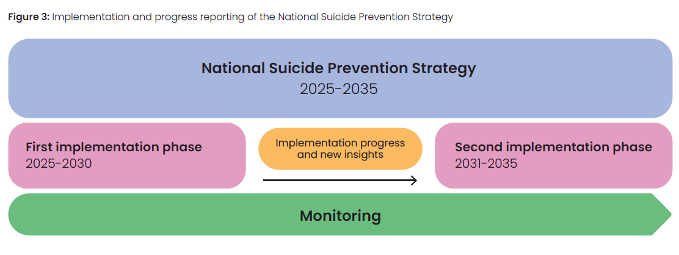The Strategy has been designed to be implemented over a 10-year period, with two 5-year implementation phases that should be monitored and reported on. The two implementation phases allow for review and adjustment in line with progress and new evidence.

At its heart, the Strategy asks governments, agencies, services, and all members of the community to recognise their role in suicide prevention and work together to achieve change. There is no task that is more essential.

# Sources of support

If you or someone you know is experiencing distress, please ask for help. Support is always available. Below are options for online and telephone information and support in Australia.

